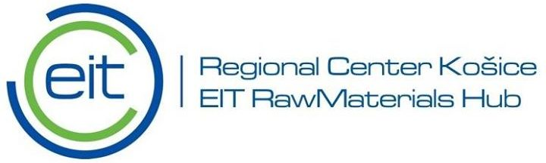

Enterpreneurship course and practical geology/ geodesy/ mineral processing field education
APPLICATION FORM
I Personal data
- Name and surname ……………………………………………………………………………….
- ID number (passport or identity card) ……………………………………………………...
- Home address ……………………………………………………………………………..........……
- Phone number ………………………………………………………………………………………….
- E-mail address ………………………………………………………………………………………….
- Person to contact in case of need:
  - Name and surname ……………………………………………………………………
  - Phone number ………………………………………………………………….………….
II University and education aspects
- University/ Institute …………………………………………………………………………………………………..
- Field of study ……….……………………………………………………………………………………………………….
- Field of interest …………………………………………………………………………………………………………….
- Nr. of completed semesters ………………………………………………………………………………………….

III Attachments
- Motivation Letter (1000 words). Explain why you want to participate and how the participation can contribute to the development of your career.
- Additional activities (confirmed by the dean). This can be documented work in a student scientific club or other scientific organization, presented lectures at student scientific sessions, seminars and conferences, published articles in scientific and popular science journals etc.
- Please provide documentation of the average grades for the semesters of completed studies
By my signature I confirm that I am in a suitable health condition to take part in the programme and I will arrange a health insurance that will cover me during the whole course duration (the cost of the insurance will be covered by Technical University of Kosice along with all the other travel costs during the whole duration of the course, including travel to and from the course destination).
Place and date: Signature:
The applications and attachments have to be sent to: jana.smihulova@tuke.sk

